Explaining variance and quantifying performance

14.8 – Manual Tuning
The key benefit of using machine learning models is that they can automatically find the best-fitting parameters that allow the model to perform with acceptable accuracy. No need for us to painstakingly set the parameters that combine our input variables to yield a model with the best possible performance. Instead, weights are adjusted through numerical optimization over many training examples, slightly changing millions of parameters on each iteration to improve accuracy by a little. This is not a human endeavor and an impossible undertaking at this point to even attempt, given the complexity and the sheer number of parameters in even modest machine learning models in production. So, you might be surprised that we will pick the parameters for our first linear regression model by hand in this section. We will get to an automated approach soon enough (in the next section). But first, we need to define precisely how we measure, numerically and objectively, the performance of our machine learning model. We can derive, compute, and compare these performance metrics without learning. So, for simplicity, we will use common sense, rather than numerical optimization, to create a few machine learning with varying performance levels.

14.9 – Defining our model
We will start our discussion with a straightforward regression model to predict a patient's total medical expenses based on age. The data we will use for this can be found in Figure 14.8b, which, as discussed, is a small toy dataset based on only 20 data points out of roughly 1000 datapoint in the original dataset. Our model will have two parameters a and b, where a is the slope or directional coefficient of the function that maps x (age) to y (medical expenses), and b is the bias, intercept or offset (as discussed before, all three terms refer to the same thing, the names just originated from different disciplines). Therefore, Equation 14.1 defines our linear regression model that uses age to predict medical expenditures, assuming a linear relationship between the two variables.

(14.1)
Equation 14.1 - Our general linear regression model. Our prediction y is a function of x times parameters a (the slope) plus parameter b (the offset or intercept)

14.10 - Quantifying performance
The usefulness of any machine learning model is a function of how well it performs across a wide range of inputs. How we quantify performance depends, amongst other things, on the algorithm we use. Whereas the performance of a classification algorithm should be reflected in the accuracy of its predictions, what constitutes an accurate prediction for a regression algorithm is less well defined. Instead, we need to rely on some measure of getting at least reasonably close to the actual output value we are trying to predict. And what constitutes reasonable isn't necessarily a given either. Therefore, a model's performance in regression is quantified in terms of how well it explains the data: the model's 'goodness-of-fit'. For regression, we typically use the r-squared value, or its more official and serious name: the coefficient of determination.

14.11 - The intuition behind the R-squared metric
In the next paragraph, we will detail the formulas we need to compute the r squared. Here, we focus instead on the intuition that underlies measuring performance. First, let us briefly revisit the material discussed in chapter 13. In this chapter, we defined several key statistical metrics, like the mean, variance, and standard deviation of a random variable x. If you have read chapter 13 or have a solid knowledge of statistics, these concepts should now be familiar. For example, when we measure the height of a randomly selected group of individuals, we understand that we can compute a mean height and some variation around that height from this sampling. In statistics, these metrics will serve to compare, contrast, and estimate, with some probability or statistical significance, the difference between different groups of individuals. For example, we could test whether the Dutch are significantly taller than people from Uruguay. Not all Dutch individuals need to be taller than all Uruguayans; that is a far too stringent statistical criterium. Instead, we want to show that the mean height of the Dutch is different enough (statistically speaking) from the mean height of the Uruguayan people. In machine learning, we use highly similar metrics to quantify machine learning model performance but with a small but significant difference. In statistics, we are mainly concerned with the variance we observe within a particular random variable x. In machine learning, we want to condition that variance on how much of that variance can be explained by our model and how much variance is left over that cannot be explained by our model. In this context, we should not equate "explaining" to some conceptual scientific explanation based on our model. Rather, think of it as our model's ability to capture the natural variation we see in our outputs. The output of a high-performing model will correlate with the actual outputs because it has found some combination of inputs from which it can produce an output that correlates and varies very similarly to the actual ground truth outputs. Again, the model isn't engaged in finding a conceptual framework for how a person's IQ depends on genes, environment, access to certain resources, diet, etc. That will be the human scientific interpretation of the model. The model, mathematically speaking, just aims to have its prediction move in unison with ground truth data.


Figure 14.9 - There are differences in the average height of individuals between nations. The origin of the exceptional height of the Dutch has been studied extensively, suggesting it is a combination of natural selection (the Dutch value height in choosing a partner) and diet.

For example, imagine we measure the IQ of a modest number of people. When we discover that an individual has an IQ of 200, we ought to be surprised. After all, an IQ that high is so extremely rare (statistically speaking) that it has only been measured in a handful of people. In a way, machine learning aims at tempering this surprise. With the right model, we could explain the high IQ in some way: We would agree that an IQ of 200 is rare. But we would further point out that the person with that IQ had parents who both had high IQs. We then point out that our model has found that aspect to be highly predictive of a person's IQ. We would therefore conclude that an IQ of 200 is still quite surprising, but less so, given the circumstantial evidence. We have explained some of the variance we observed in our data. Note that we are not trying to explain these highly unusual data points. Instead, we are trying to explain the variance across all data points. If someone has an IQ very close to the population mean, our model must still get that right. In this case, it will probably rely on the absence of factors that typically push a person's IQ to be exceptionally high (or low).



Figure 14.10 - IQ validity, precision, and use have remained controversial ever since their inception by French psychologist and neuroscientist Binet. "IQ is what an IQ test measures" is a joke amongst psychologists and acknowledges that the test seems to measure some stable and reproducible quantity that varies across people but that it is unclear how exactly it relates to human intelligence as a broad and multifaceted quality that can take on many different forms. That doesn't mean there are some brilliant individuals, like mathematician Terence Tao and physicist Marie Curie, both with estimated IQs of around 200. Note that Marie Curie was one of 4 people ever to have been awarded the Nobel Prize twice.

However, suppose we can't find the right reasons to explain why we observe an exceptionally high IQ. In that case, we might be forced to conclude that the variation in IQ is unexplainable and due to some random process or that we simply did not include the things to are predictive as inputs to our model, possibly phrased as follows: "that person has an IQ of 200? That is surprising, given our model has found nothing that would have predicted that happening. Either we missed some crucial aspect, or IQ is still more or less random". We will typically find ourselves somewhere in between these two extremes. We can discover predictive things, but they rarely are entirely deterministic. We might overlook or not have measured other variables that could add predictive variance explaining power. And we are bound to have some measurement error in our data to begin with, which can never be explained. In other words, there will be residual variance in our outcome data that isn't explained by our model. To recap: in statistics, we often describe a variable's variance. In machine learning, we are interested in how much of that variance can be explained by our model. Our model, in turn, will use input data to get close to what is observed as actual output. Whatever our model cannot explain is considered residual variance. A good model will explain a substantial amount of the variance and leave little residual variance. This ratio between total, explained, and residual variance gives rise to the r-squared metric, which we will discuss next.

14.12 - SST, SSE, SSR
Formalizing the above, let us work through the computations needed to arrive at the r-squared value. In the previous chapter on statistics, we defined the mean, variance, and standard deviations and outlined the formulas we need to compute them. In machine learning, it is common practice to use the intermediate precursor metrics, which carry the same information but are not standardized and normalized. In the end, the metrics computed aren't any different. They appear to be based on different conventions and disciplines brought to the table at various points during the development of machine learning algorithms. Remember our original formula for the population variance of a variable y:

(14.2)
Equation 14.2 - The population variance of a variable y. For generic formulas that describe specific statistical properties, such as moments, we will typically use a variable x, indexed by i. In machine learning, we typically reserve x to denote an input variable and y as an output variable. This is true for Equation 14.1, which relates input variable x to output variable y. However, here x denotes any random variable over which we can compute the variance.

Notice that the last step in computing the variance is to divide it by the number of elements in variable x. In other words, the variance of variable x is an average across all elements of x. Before we normalize, however, we already have a useful precursor of variance, known as the Sum of Squares. It is called that way for an apparent reason: we square the difference between each data point x_{i} and the mean of x: (x_{i} - x)² and sum them all together. This Sum of Squares measures the variance in x and only x. We refer to it as the Sum of Squares Total or SST, defined in Figure 14.3, because it captures the total variation observed in x, independent of any other variable we could use to explain the variance in x. As we discussed above, in the context of IQ, we introduce a model to explain as much variance as possible in x. This allows us to define two more quantities, the Sum of Squares Regression (SSR, Figure 14.4) and the Sum of Squares Error (SSE, Figure 14.5). Theoretically, the SSR is the amount of SST we could explain using our model; the SSE is whatever is left over. From this, it naturally follows that SST = SSR + SSE.

(14.3)
(14.4)
(14.5)
Equations 14.3-5 - Without the normalization by the number of data points n, we get the precursors of variance of x: the sum of squares total (SST), the sum of squares regression (SSR), and the sum of squares error (SSE).

14.13 - Coefficient of determination or r-squared
The ratio between the SST and SSR into SST provides us with a metric for our model's performance: the r-squared, also known as the coefficient of determination, see Equation 14.6. Figure 14.11 shows a visualization of these different metrics using synthetic data to prime you on how to interpret the various metrics we have discussed so far. Don't worry too much about fully grasping every single detail. In the next section, we will examine how these metrics change using real data and how they yield an informative r-squared metric, which measures the so-called goodness-of-fit of our model to the data. This manual tweaking of parameters allows us to present ideal and less-than-ideal models and compare the difference in performance, as measured by the r-squared.

(14.6)
Equation 14.6 - The r-squared value measuring the goodness-of-fit or our model is given by the ratio between the sum of squares regression and the sum of squares total.

14.14 - A quick word of caution
As a quick aside, please remember that other people refer to these different quantities differently at times. Somebody might take the abbreviation SSE to mean the Sum of Squares Explained, and others will assume it is the Sum of Squares Error. Similarly, some consider SSR to mean the Sum of Squares Residual, whereas others define it as the Sum of Squares Regression. Very confusing indeed, as it comes out the exact opposite, depending on what you think the abbreviations stand for!

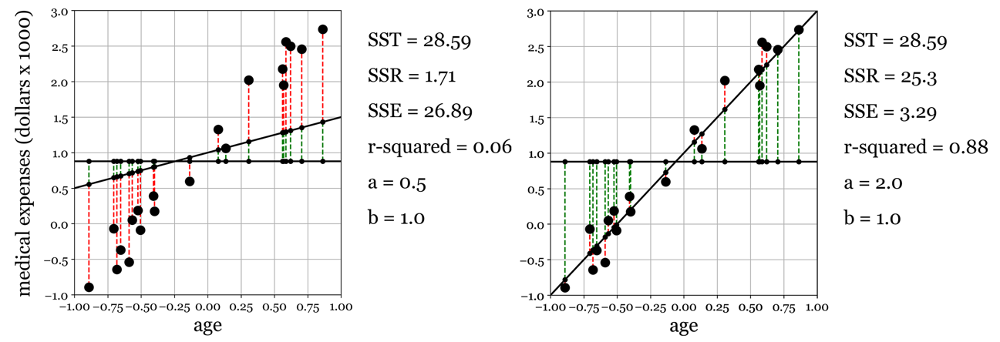
Figure 14.11 - R-squared values for two models. (A) Parameters that produce a bad fitting model explain relatively little variance in the output x (SSR), leaving most of it unexplained (SSE), resulting in a low r-squared value. (B) In contrast, parameters that yield a good fitting model will have most of the variance explained and little left unexplained, resulting in a high r-squared value.

